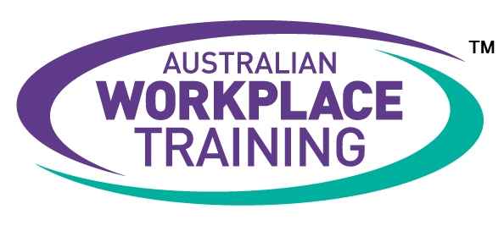

Expression of Interest
COVID Clean Training

By completing this form I acknowledge that I have received and read through the information provided to me in the following documents:
- Australian Workplace Training Student Handbook
- Australian Workplace Training Information Booklet
- Course Flyer – COVID Clean Training

First Name: | Click here to enter your First Name
Last Name: | Click here to enter your Last Name
Date of Birth: | Click here to enter your Date of Birth.
Phone Number: | Click here to enter your phone number.
Email: | Click here to enter your email address.
Course | Choose a course from the list provided

If you would like us to check your eligibility for WorkReady subsidies please complete the questions on the next page. Please be advised that:
- We will only enrol you in one of the COVID Clean Skill Sets

I acknowledge that all the information I have provided is true and correct.
I understand that this training will be undertaken via an e-learning study mode comprising a combination of online theory study and practical tasks that I will need to complete and have signed off in my workplace
Any false or misleading information can lead to my application being cancelled and/or being removed from the course.

Signature: Please enter name here | Date: Select Date:

Please email your completed form with a copy of your ID to enrolments@awt.edu.au

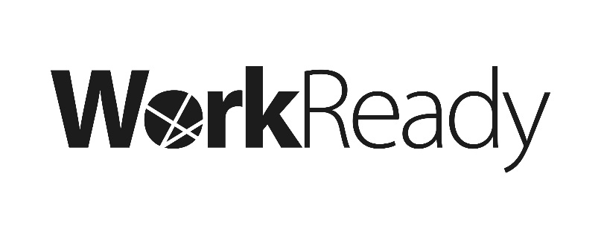
COVID Clean Training
Eligibility Checklist

Eligibility Criteria:

Do you live or work in South Australia? | Please Select:
Are you aged 16 years or older? | Please Select:
Are you registered with a secondary school (high school)? | Please Select:

Were you born in Australia? |  | Please Select:
I am a | Choose from the following:

If you were not born in Australia you will need to provide supporting documentation to demonstrate your Australian citizenship, permanent residency and/or visa status. Please provide us with your Citizenship certificate, Passport, Immicard or Documents for Travel to Australia

Have you completed any of the following qualifications (obtained in Australia)?
Please tick all that apply:

☐ SACE/Completed High School | ☐ Certificate III | ☐ Advanced Diploma
☐ Certificate I | ☐ Certificate IV | ☐ Bachelors Degree or Higher
☐ Certificate II | ☐ Diploma | ☐ I do not have any qualifications

Are you currently Employed? |  | Please Select:
If Yes,
Employer: | Please type in the name of your Employer/Company
Suburb: | Please type in the suburb for your place of employment
Postcode: | Please type in the postcode for your place of employment
Industry: | Choose the Industry of your Employment from the list provided
Are you… | ☐ in a Customer-facing Role
 | ☐ the Business Owner
 | ☐ a Supervisor within the business

